Chapter 13, Solution 80.

The schematic is shown below.

k₁ = = 0.1768, k₂ = = 0.4082

k₃ = = 0.433

In the AC Sweep box, we set Total Pts = 1, Start Freq = 0.1592, and End Freq = 0.1592. After the simulation, we obtain the output file which includes

FREQ IM(V_PRINT1) IP(V_PRINT1)

1.592 E–01 1.304 E+00 6.292 E+01

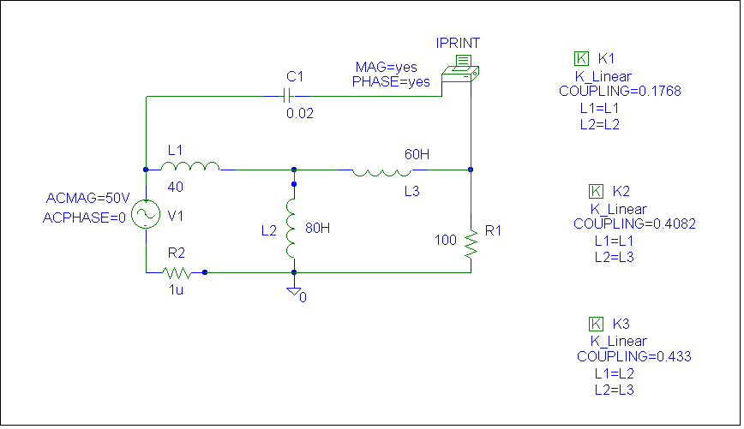
i.e. I_{o} = 1.304∠62.92° A

